Name: - Kamal Rohra

Roll no: -1911111

Partner: - sanket saboo(1911112)

**Simple select query: -**

Explain: -

Code: -

explain select * from user;

Output: -

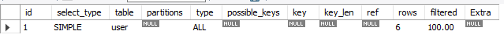

Explain analyze: -

Code: -

explain analyze select * from user;

Output: -

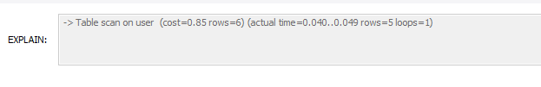

**Select query with join: -**

Explain: -

Code: -

explain select * from user

inner join ticket

on user.user_id = ticket.user_id;

OUTPUT: -

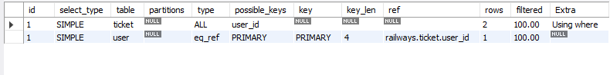

Explain analyze: -

Code: -

explain analyze select * from user

inner join ticket

on user.user_id = ticket.user_id;

Output: -

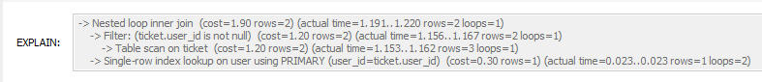

**Select query with where clause: -**

Explain: -

Code: -

explain select * from user where first_name = "sanket";

Output: -

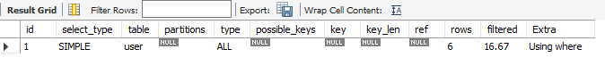

Explain analyze: -

Code: -

explain analyze select * from user where first_name = "sanket";

Output: -

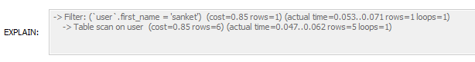

**Index: -**

Code: -

create index users_first_name on user(first_name);

explain analyze select * from user where first_name = "sanket"

Output: -

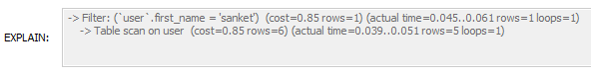

|  |
| --- |
| -> Index lookup on user using users_first_name (first_name='sanket') (cost=0.35 rows=1) (actual time=0.113..0.116 rows=1 loops=1) |

**After dropping index: -**

Code: -

drop index users_first_name on user;

Output: -

